# Computer Porgramming Lab 11

**Nabeel Ali BEE173059 Section-3**

## Activity 1:

#include <stdio.h>

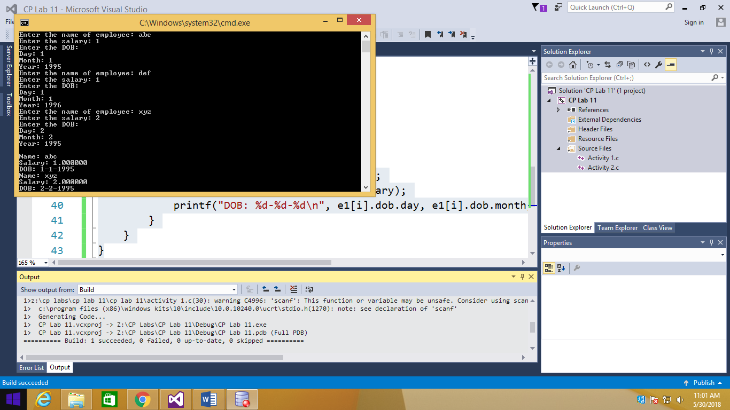struct Date

{

int day, month, year;

};

struct Employee

{

char name[20];

float salary;

struct Date dob;

};

main()

{

struct Employee e1[3];

int i;

for (i = 0; i < 3; i++)

{

printf("Enter the name of employee: ");

scanf("%s", e1[i].name);

printf("Enter the salary: ");

scanf("%f", &e1[i].salary);

printf("Enter the DOB: \n");

printf("Day: ");

scanf("%d", &e1[i].dob.day);

printf("Month: ");

scanf("%d", &e1[i].dob.month);

printf("Year: ");

scanf("%d", &e1[i].dob.year);

}

printf("\n");

for (i = 0; i < 3; i++)

{

if (e1[i].dob.year == 1995)

{

printf("Name: %s\n", e1[i].name);

printf("Salary: %f\n", e1[i].salary);

printf("DOB: %d-%d-%d\n", e1[i].dob.day, e1[i].dob.month, e1[i].dob.year);

}

}

}

## Activity 2:

#include <stdio.h>

#include <math.h>

float distance(struct Point p1, struct Point p2);

struct Point

{

float x, y;

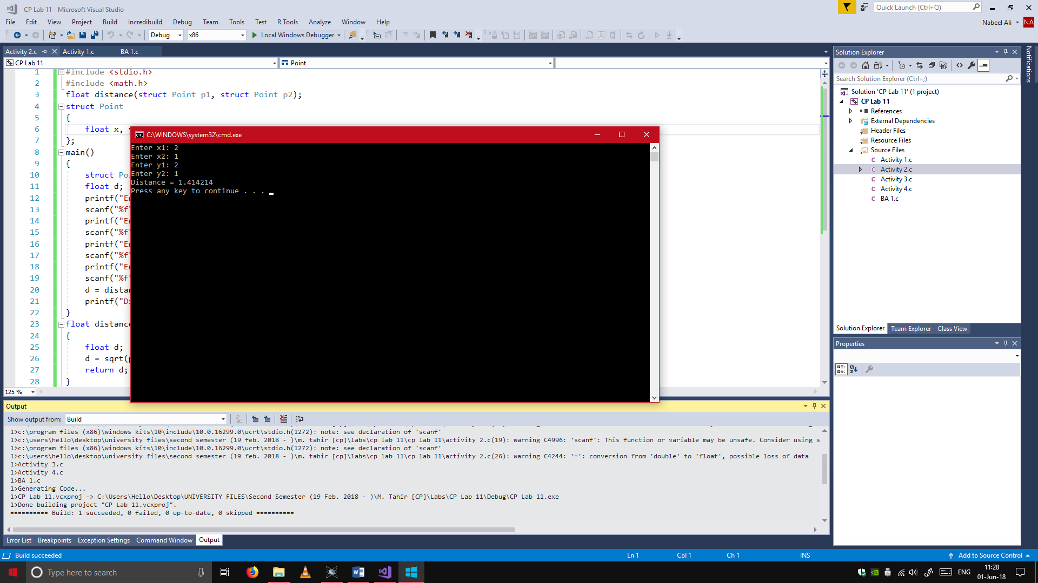};

main()

{

struct Point p1, p2;

float d;

printf("Enter x1: ");

scanf("%f", &p1.x);

printf("Enter x2: ");

scanf("%f", &p2.x);

printf("Enter y1: ");

scanf("%f", &p1.y);

printf("Enter y2: ");

scanf("%f", &p2.y);

d = distance(p1, p2);

printf("Distance = %f\n", d);

}

float distance(struct Point p1, struct Point p2)

{

float d;

d = sqrt(pow((p2.x - p1.x), 2) + pow((p2.y - p1.y), 2));

return d;

}

## Activity 3:

#include <stdio.h>

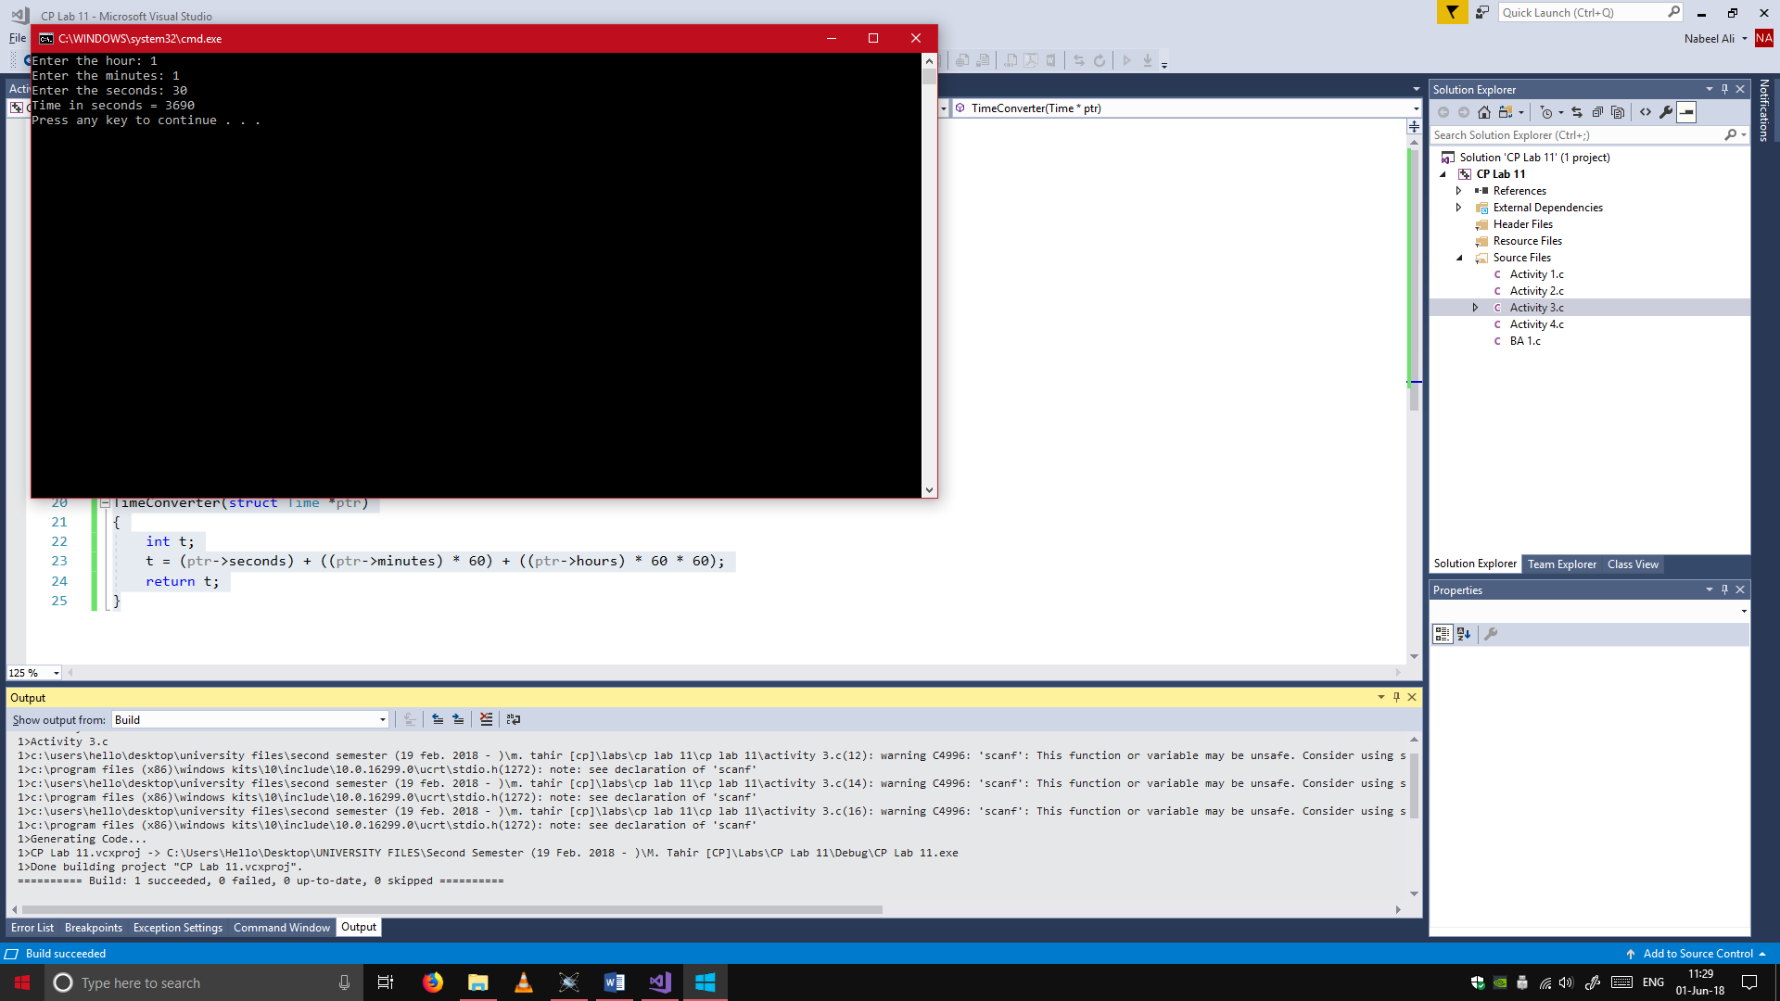TimeConverter(struct Time *ptr);

struct Time

{

int seconds, minutes, hours;

}

main()

{

struct Time t1;

int t;

printf("Enter the hour: ");

scanf("%d", &t1.hours);

printf("Enter the minutes: ");

scanf("%d", &t1.minutes);

printf("Enter the seconds: ");

scanf("%d", &t1.seconds);

t = TimeConverter(&t1);

printf("Time in seconds = %d\n", t);

}

TimeConverter(struct Time *ptr)

{

int t;

t = (ptr->seconds) + ((ptr->minutes) * 60) + ((ptr->hours) * 60 * 60);

return t;

}

## Activity 4:

#include <stdio.h>

struct Book

{

char title[20];

int pages;

float price;

};

union Journal

{

char title[20];

int pages;

float price;

};

main()

{

struct Book b1;

union Journal j1;

printf("Enter the title of the book: ");

scanf("%s", b1.title);

printf("Enter the number of pages in the book: ");

scanf("%d", &b1.pages);

printf("Enter the price of the book: ");

scanf("%f", &b1.price);

printf("Enter the title of the journal: ");

scanf("%s", j1.title);

printf("Enter the number of pages in the journal: ");

scanf("%d", &j1.pages);

printf("Enter the price of the journal: ");

scanf("%f", &j1.price);

printf("\nSize of book: %d\n", sizeof(b1));

printf("Size of journal: %d\n", sizeof(j1));

printf("\n\n");

printf("Title of book: %s\n", b1.title);

printf("Number of pages in the book: %d\n", b1.pages);

printf("Price of the book: %f\n", b1.price);

printf("\n");

printf("Title of journal: %s\n", j1.title);

printf("Number of pages in the journal: %d\n", j1.pages);

printf("Price of the journal: %f\n", j1.price);

}

